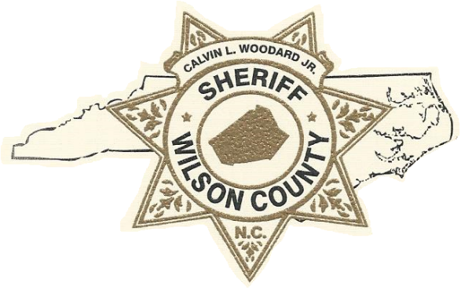Pistol Purchase Permits

Hours of Operation:

* 9:00 a.m.–4:00 p.m., Monday - Friday

Questions call:

* 252-237-2118

Applicant requirements for a Pistol Purchase Permit:

* Must be 18 years old
* Must be a resident of Wilson County for a minimum of 30 days
* Must have a valid NC Driver's License or NC ID Card displaying your current residential address.
* Resident Aliens: Must bring a resident alien card, social security card and a NC driver’s license or NC ID card
* Military personnel must bring form DD-214 (discharged).
* Naturalized Citizens: Must bring your Naturalization Certificate or valid US Passport
* U.S. Citizens born outside of the U.S.A. to U.S. parent(s) must bring your documentation from the Department of State (Consular Report of Birth Abroad, Certificate of Citizenship, or Certification of Report of Birth)
* Must NOT be convicted of any felony, or similar offense in any jurisdiction or currently under indictment for any felonious offense
* Must NOT be a fugitive from justice
* Must NOT be an unlawful user of, or addicted to, marijuana, any depressant, stimulant or narcotic drug
* Must NOT be adjudged incompetent on grounds of mental illness, nor have been committed to any mental institution  
  ***\*\*Effective December 1, 2015, North Carolina General Statute 14-404(e1) requires applicants to sign a release of court orders concerning mental health and capacity for pistol purchase permits.******\*\*The Wilson County Sheriff’s Office accepts walk-ins.***
* Must NOT be convicted of a Domestic Violence Offense
* Must NOT have unresolved criminal charges pending
* Must NOT have a suspended driver's license
* Must NOT have a substantial history of convictions, arrests, or reports demonstrating a continuing pattern of criminal activity
* Must NOT be discharged from the Armed Forces under dishonorable conditions
* Must NOT be an illegal alien or unlawfully residing in the United States
* Must NOT have been a citizen of the United States and renounced that citizenship

To apply for a pistol permit you may fill out the application online or in person:

* **ONLINE: Complete application, deliver it to Wilson County Sheriff’s Office in person and pay applicable fees.**
  + [Apply here](Pistol-Purchase-Permit-Application.pdf) to start the process or return to the main screen to fill out the application.
* Fill out Release of Mental Health Form
* **In Person:**
  + Wilson County Sheriff’s Office  
    100 Green Street E., Wilson, N.C. 27894
    - Present a valid North Carolina Driver License or ID card
    - Present five US dollars ($5.00) per requested permit upon application
* **When your permit(s) are ready:**
  + You must appear in person at:

Wilson County Sheriff’s Office  
 100 Green Street E., Wilson, N.C. 27894

* + The permits process takes approximately fourteen (14) days upon submitting the application.
  + Present a valid North Carolina Driver License or ID card
  + Permits must be picked up by the applicant within twenty-eight (28) days of notification or you will have to re-apply.

Fees:

* **In Person:**
  + Five US dollars ($5.00) per permit due with application (Cash, Credit or Debit), Non-refundable.

If your Permit Request Is Denied, you will be notified:

* + In writing, within (45) days, as to why it was denied.

What do I do if my permit is refused?

* + You may appeal the decision to the Superior Court Judge of Wilson County.

How do I appeal?

* North Carolina General Statute 14-404 provides that when an individual has been refused a pistol permit or had a pistol permit revoked by the Sheriff, the individual has the right to appeal the refusal / revocation.
  + The individual may appeal the decision by submitting a written or typed petition (statement) to the Superior Court Judge setting forth the reasons for appeal.
  + The petition along with a copy of the Sheriff’s notice of refusal / revocation must be submitted with a filing fee of $200.00 and a $30.00 service fee (personal checks will not be accepted) to the Clerk of Superior Court, Civil Division, Wilson County Courthouse located at 115 Nash Street E., Wilson, NC 27893.
  + Generally, appeals of refusal / revocation of pistol permits are considered by the Superior Court Judge. The determination by the court, on appeal shall be upon the facts, the law, and the reasonableness of the Sheriff’s refusal. The determination by the court is final. The Superior Court Judge will notify the individual of his/her decision.

Buying and Selling Pistols

* You must obtain a valid pistol permit, whether you receive the weapon from a commercial dealer or a private person. The requirement also applies without regard to whether it is a transaction for money or a gift.
* It is a misdemeanor to sell or otherwise dispose of a handgun without first obtaining a pistol permit from the recipient of the pistol.

***\*\* It is your responsibility to know the NC Firearms Laws. Below is a link to the NC Firearms Laws (NCSA) and a downloadable copy of the Wilson County Ordinances (Firearms pp. 20-21). \*\****

[[](http://ncdoj.gov/Files/About-DOJ/Law-Enforcement-Liaison/NC-Firearms-gun-Laws.aspx)NC Department of Justice](https://ncsheriffs.org/wp-content/uploads/Master-Firearms-Publication-October-2018.pdf)  
[[](http://www.wakegov.com/sheriff/divisions/Documents/Firearms%20Ordinance%202005.pdf)Wilson County Ordinances (Firearms pp. 20-21](https://www.wilson-co.com/home/showdocument?id=5019)).